**I’m really sorry that I’ve some bug in the code when computing Cramer’s V. Richard is right, the stat just doesn’t change much.**

**Contingency analysis**

|  |  |  |  |
| --- | --- | --- | --- |
|  | Early | Midday | Late |
| D1 | 3 | 1265 | 24 |
| D2 | 7828 | 47400 | 1715 |
| O | 5149 | 28287 | 840 |
| Q | 1423 | 9523 | 494 |

*Table 1 (Contingency Analysis for # of Transaction)*

Cramer’s V is 0.04832802 – weak relationship

Instead of making a frequency table, I attach a mosaic plot instead.

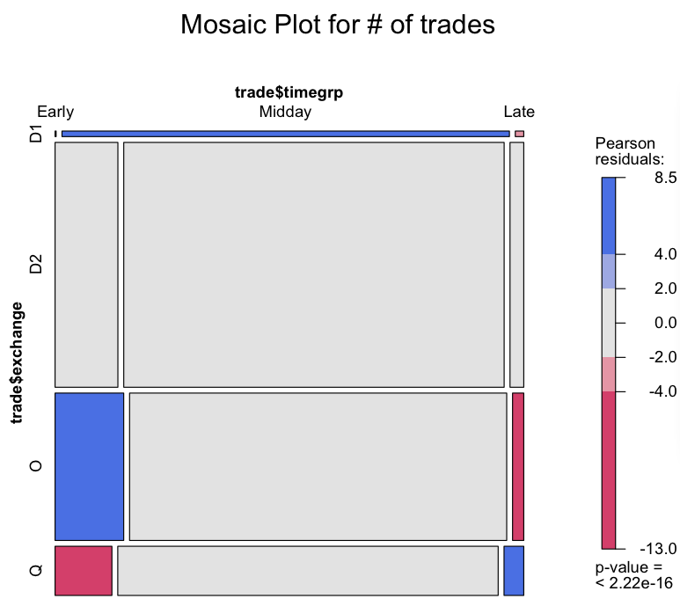

Figure 1

Interpretation of mosaic plot is straightforward. We interpret positive values (label in blue) as showing cells whose observed frequency is substantially greater than would be found under independence; negative values (label in red) indicate cells which occur less often than under independence.

In this mosaic plot, most of the cells are not significant.

|  |  |  |  |
| --- | --- | --- | --- |
|  | Early | Midday | Late |
| D1 | 771 | 289821 | 5135 |
| D2 | 1482682 | 11042741 | 368502 |
| O | 633770 | 3818988 | 98148 |
| Q | 180865 | 1411640 | 83055 |

*Table 2 (Contingency Analysis for # of shares)*

Cramer’s v = 0.04946721

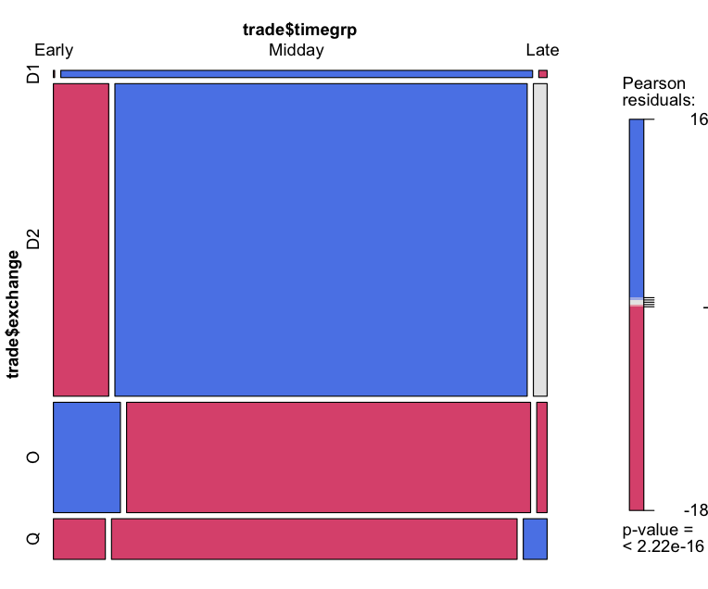

Figure 2

If we focus on the number of shares, the mosaic plot will be completely different. Most of the shares are traded in midday in D as “block trades”. In general, Apple stock traded in midday is more likely to be traded in exchange D; AAPL traded in early morning is more likely to be trades in other exchange; AAPL traded in late time is more likely to be traded in the primary exchange.

However, as we use Pearson residual (chi-square) test here, number of share MAY magnify chi-square test. So we conclude that the result is not significant, and the result of mosaic plot is not significant as well.

If we compare D2 vs non-D2, the result is not significant at all.

|  |  |  |  |
| --- | --- | --- | --- |
|  | Early | Midday | Late |
| Non-D2 | 6575 | 39075 | 1358 |
| D2 | 7828 | 47400 | 1715 |

*Table 3 (Contingency Analysis for # of Transaction)*

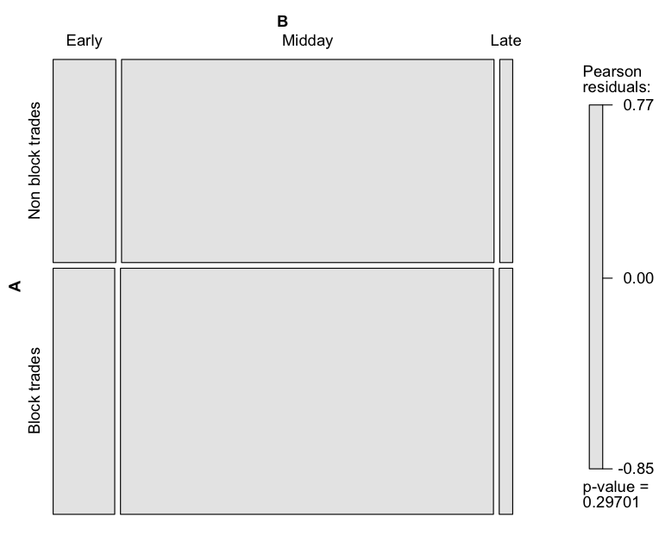

Figure 3

|  |  |  |  |
| --- | --- | --- | --- |
|  | Early | Midday | Late |
| Non-D2 | 815406 | 5520449 | 186338 |
| D2 | 1423 | 9523 | 494 |

*Table 2 (Contingency Analysis for # of shares)*

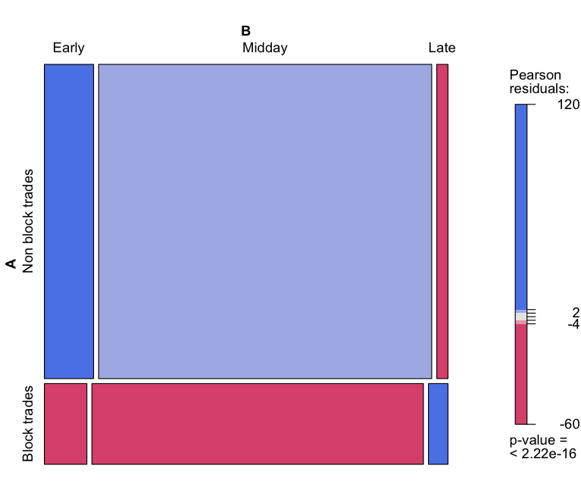

Figure 4

Cramer’s v for table 3 and table 4 are 0.004832872 and 0.0507463. So for table 4, it we can say there are some weak relationship between time and location

From the mosaic plot, we can see that non-D2 is more likely to be traded in the morning, and D2 is more likely to be traded in the late 10 minutes. Again, result is not significant.

**Multinomial Logistic Regression**

**Model: In $\frac{P(exchange=?)}{P(excahnge=B)}$ = $β_{0}$ + $β_{1}×I_{Midday}$ + $β_{2}×I_{Late}$**

|  |  |  |  |
| --- | --- | --- | --- |
|  | Intercept | IMidday | ILate |
| D2 | 7.866580 | -4.243032 | -3.597384 |
| O | 7.447675 | -4.340347 | -3.892246 |
| Q | 6.161640 | -4.143005 | -3.137077 |

Table 5 (Coefficients of MLR model)

The negative log-likelihood for this model is 102959.091624, which is much better than the previous ones (more than 150000)

**Interpretation:**

An example of interpretation of coefficient of indicator variable:

**In $\frac{P(exchange=D2)}{P(excahnge=D1)}$ = 7.866580 -4.243032 $×$ IMidday -3.597384 $×$ ILate**

* The log odds of trade happening in exchange D as D2 vs D1 will decrease by 4.243032(b_12) if moving from time=early to time=midday
* The log odds of trade happening in exchange D as D2 vs D1 will decrease by 3.597384(b_13) if moving from time=early to time=late
* The result displays trades happening later in a day in exchange D is more likely to be classified as D1.